**Café Invoice Management System**

The client’s need is a software that can help him to manage the order, payment, Report

**Requirements:**

**1. Menu Management:** The software should allow the cafe to manage their menu, including adding or removing items, updating prices, and setting up specials or promotions.

**2. Order Management:** The software should allow the cafe to take and manage orders, including tracking the status of each order, adding or removing items, and updating the order total.

**3. Payment Processing:** The software should be able to process payments, including cash, credit card, and mobile payments. It should also be able to generate invoices and receipts.

**4. Reporting and Analytics:** The software should provide detailed reports and analytics on sales, revenue, and other key performance indicators. It should also allow the cafe to track customer behavior and preferences.

**5. Customer Management:** The software should allow the cafe to manage customer information, including contact details, order history, and loyalty program information.

**6. Integration with Other Systems:** The software should be able to integrate with other systems used by the cafe, such as accounting software or loyalty program software.

**7. Security and Access Control:** The software should have strong security features to protect customer and business data, including access control and data encryption.

**8. User-Friendly Interface:** The software should have an intuitive and user-friendly interface that is easy to use and navigate.

**9. Mobile Compatibility:** The software should be compatible with mobile devices, allowing staff to take orders and process payments from anywhere in the cafe.

**Risks:**

1. The software should be secured the financial details should not be accessible to everyone. It should have the security features like secured password and should only accessible to the manager and employee.
2. Monitor the software regularly to identify new threats or weakness.
3. Software bugs, network connectivity problems can cause technical glitches that may result in incorrect billing .
4. Any failure in the software can result in loss of customer and financial report.

**Configure JIRA for managing the project to solve the identified problem.**

**STEP-1: In the name icon enter your project name and click on**

**Create**

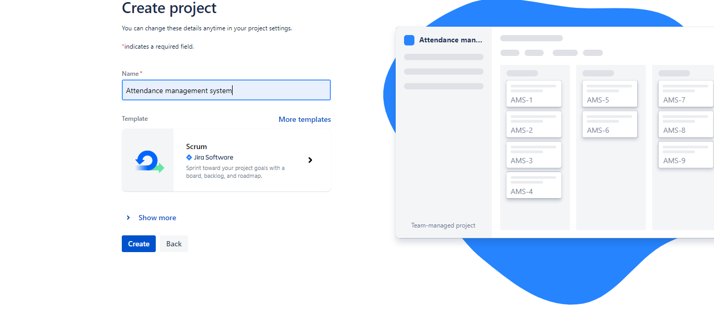

**STEP-2: Click on backlog button and create issue in backlog. Drag**

**the issues from backlog to sprint**

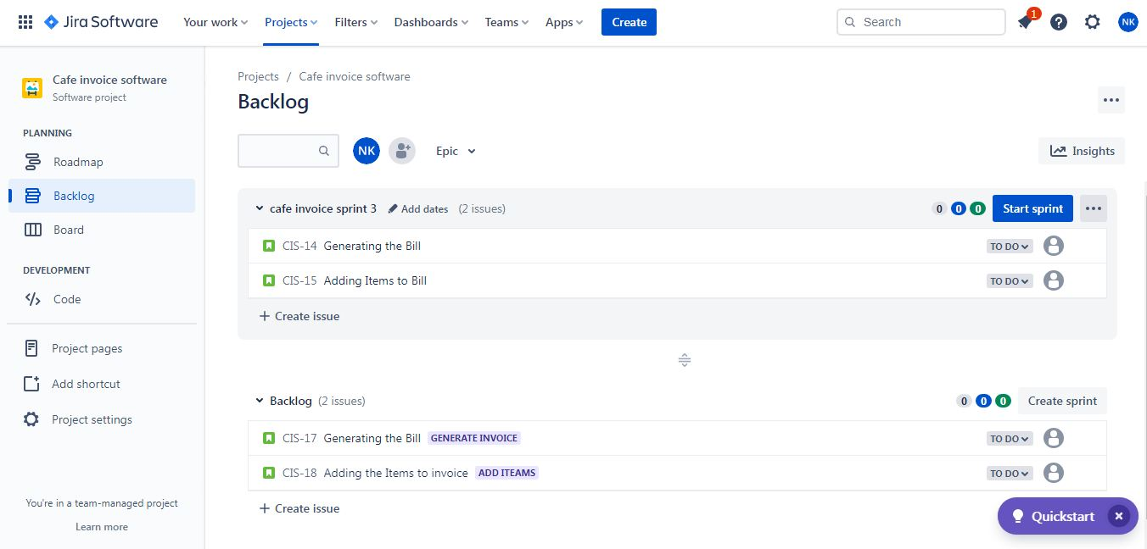

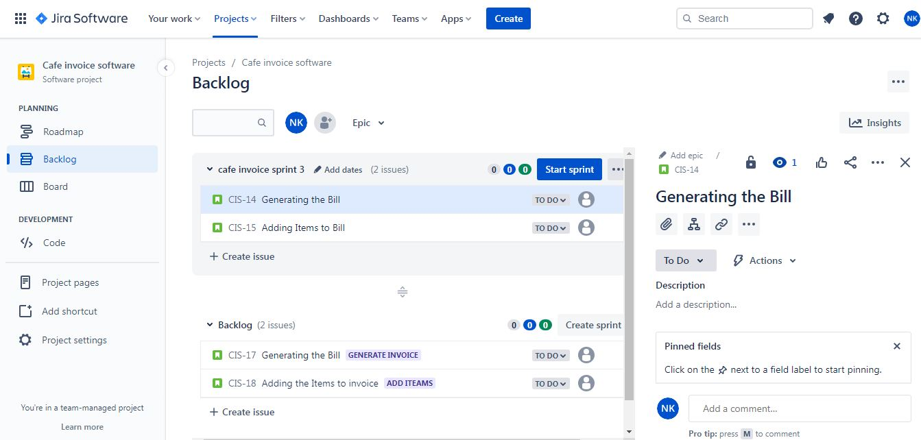

**STEP-3: Click on board and drag the issues to its respected fields**

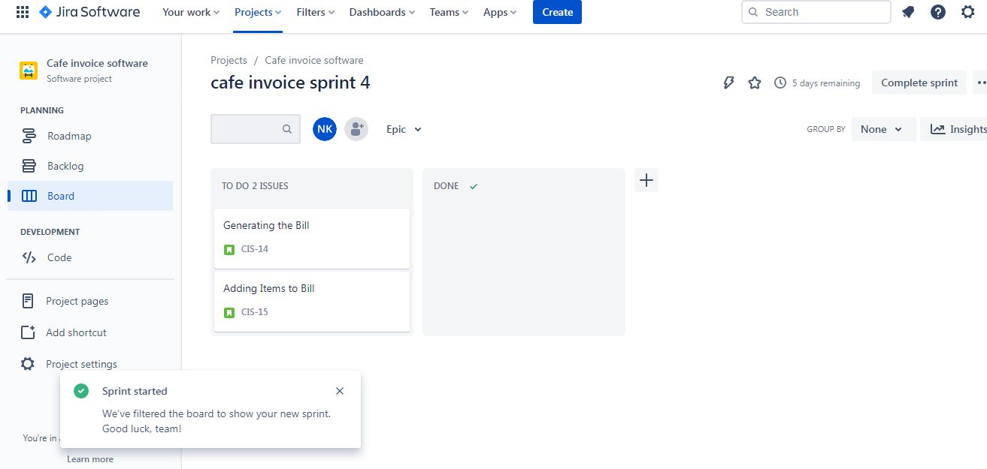

**STEP-4: Click on roadmap and create Epic and child process**

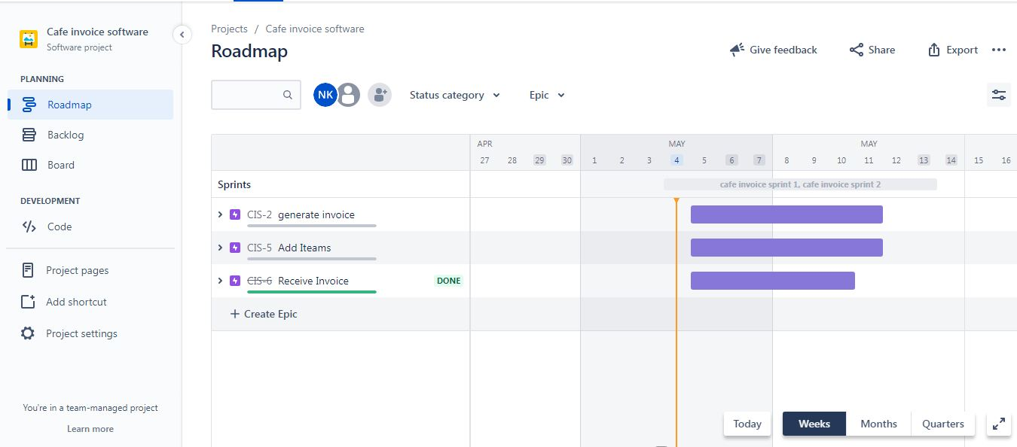

**STEP-6: Share the project with users.**



**UML Diagram:**

**USE CASE Diagram**

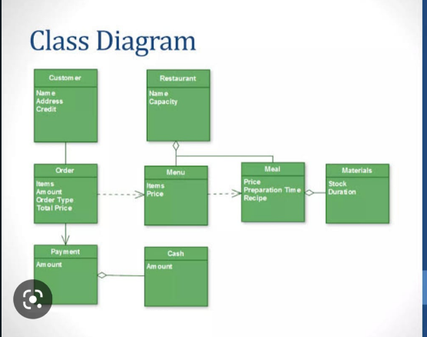

**User Stories:**

|  |  |  |
| --- | --- | --- |
| **Title:** Generate Invoice | **Priority**: High | **Estimation:** 2 |
| **User story:** Owner  As a first time user of the cafe invoice software,  I want to be able to generate invoices for my customer quickly and easily,  So that I can streamline my billing process and improve customer statisfication. | | |
| **Acceptance Criteria:**  Given that the new user want to generate invoice using software,  When the items details are entered,  Then the billing can be done easily. | | |

|  |  |  |
| --- | --- | --- |
| **Title:** Add items | **Priority:** Low | **Estimation:** 2 |
| **User story:** Employee  As a employee of Cafe,  I want to be able to add items to customer's order and generate an invoice with a breakdown of total cost,  So that I can provide accurate and efficient service to customer. | | |
| **Acceptance Criteria:**  Given that the employee should be able to add items to the customer invoice,  When employee add the items it should automatically calculate the total amount taxes and total amount,  Then the invoice should be generated accurately. | | |

|  |  |  |
| --- | --- | --- |
| **Title:** Receive an invoice | **priority:** High | **Estimation:** 2 |
| **User story:** Customer  As an customer of cafe,  I want to receive an itemized invoice that shows the items order, their prices, taxes and total amount,  So that I can review my purchase and ensure this accuracy. | | |
| **Acceptance Criteria:**  Given that the customer want itemized invoice ,  When customer receives the invoice,  Then the proper items, taxes, prices should be there. | | |

**Test plan (Suite) for the above user using Jira.**

**Step-1: Install Zephyr scale-Test management for JIRA**

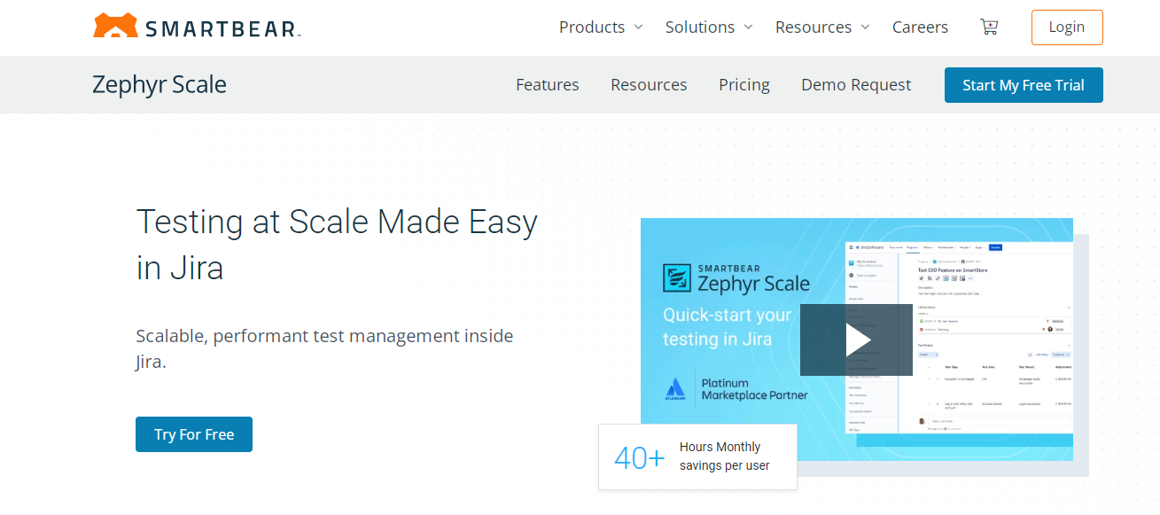

**Step-2: Create test suite(case) for your project**

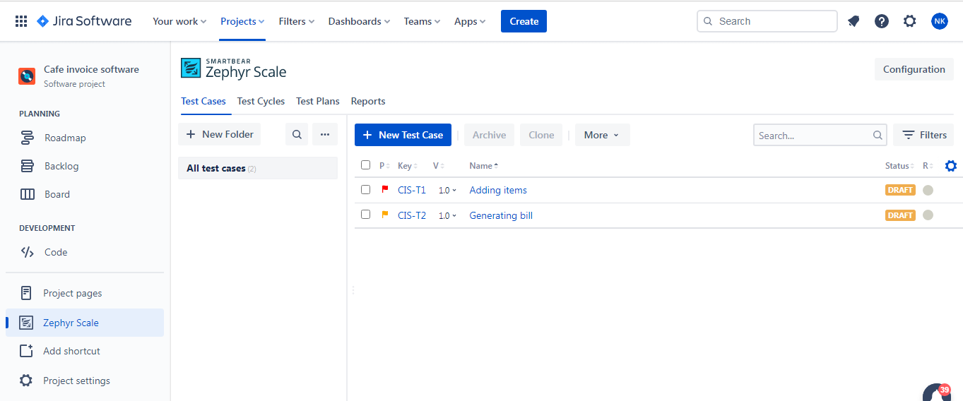

**Step-3: Add details for your test suite(case)**

